Promotional toolkit
Hate crime face covering campaign

Facebook: 940x788 px

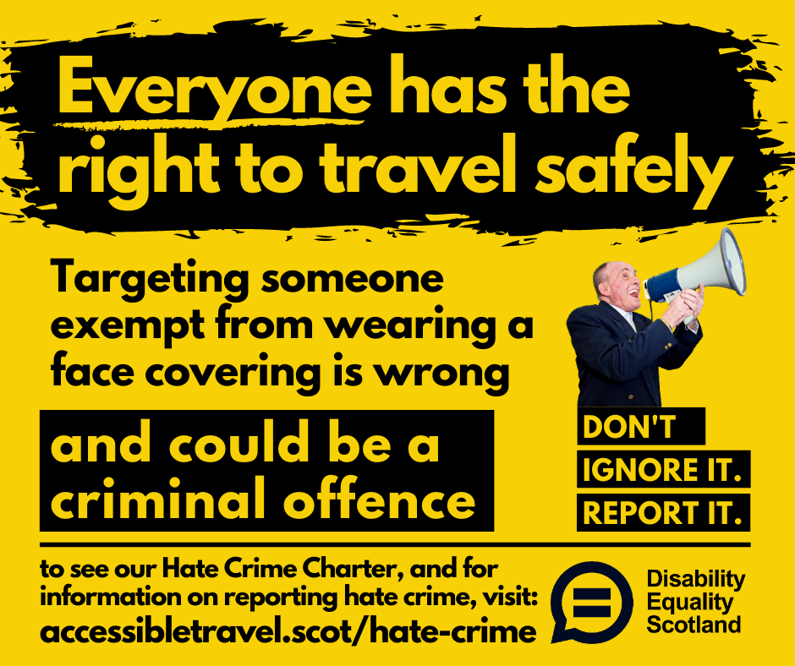

Twitter: 1200x630 px

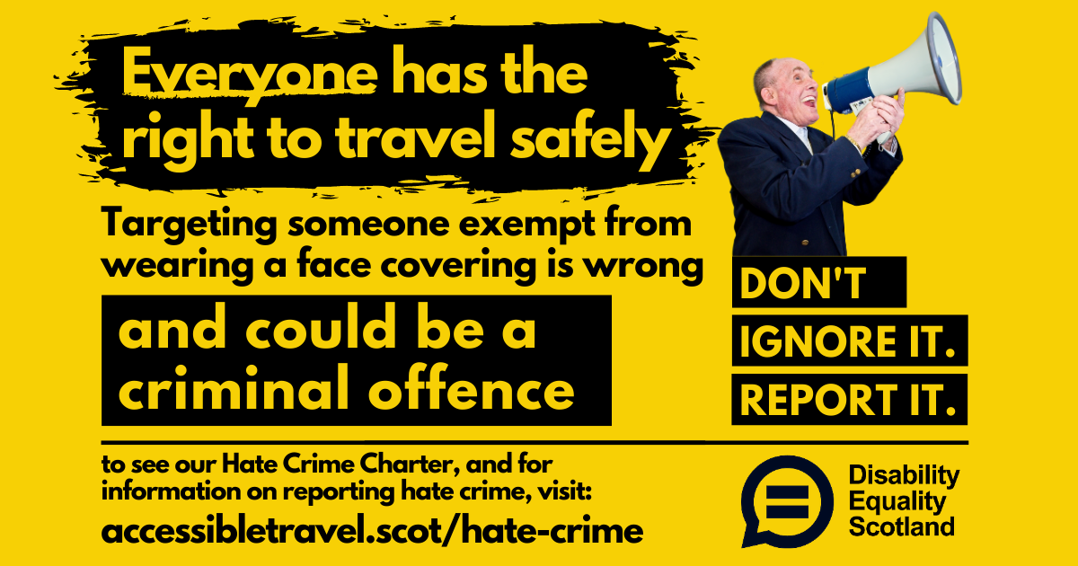

Messaging
- Not everyone can wear a face covering
- Be tolerant
- If you have concerns, speak to a member of staff – don't challenge anyone.
- Reporting Hate Crime can help to stop it. There are many ways to do this.

Key messages
We’re supporting Disability Equality Scotland to raise awareness of face covering exemptions. Not everyone can wear a face covering. Please be tolerant. Find out more at www.accessibletravel.scot/hate-crime

Disability Equality Scotland reminds everyone that some people cannot wear a face covering and are exempt. If you see someone on your journey not wearing a face covering – please be kind. www.accessibletravel.scot/hate-crime

There are many ways to report a hate crime. Reporting it helps to combat it. Find out more at www.accessibletravel.scot/hate-crime

Twitter handles to use please (includes full working group)
@DEScotTweets - Disability Equality Scotland
@transcotland - Transport Scotland
@PSsafercomms – Police Scotland Safer Communities
@ScotRail – ScotRail
@FirstScotland
@FirstinGlasgow
@FirstAberdeen
@StagecoachEScot- StageCoach
@SEStran - SESTran
@BTPScotland - British Transport Police

Hashtags
#DontIgnoreItReportIt
#NotEveryoneCanWearOne

News article
Disability Equality Scotland has been engaging with its members over the various impacts of COVID-19. One of the key concerns that has been raised relates to face covering exemptions. Face coverings became mandatory in Scotland on public transport on 22 June but there are many reasons why some people are exempt from wearing a covering, such as having a health condition or disability, including hidden disabilities.

Disability Equality Scotland’s research found that disabled people were being confronted by members of the public for not wearing a face covering and that almost 90% of respondents were fearful of being a victim of hate crime when not wearing a covering. This behaviour is unacceptable and must not be tolerated.

As such, (insert name of transport provider) is supporting Disability Equality Scotland’s campaign to raise awareness of face covering exemptions and is reminding passengers to be more tolerant. Not everyone can wear a covering. If you see someone not wearing a face covering, please do not challenge them; people who are exempt do not need to prove their exemption.

(Name of transport provider) is providing a safe space for everyone to travel.

Emma Scott, Operations Manager at Disability Equality Scotland said “We are very concerned over the numbers of disabled people who have been challenged by strangers. It’s really important to share the message that not everyone can wear a face covering and those who are not able to wear one should not be challenged. We are asking for everyone to be more tolerant of others.”

